REMO VIRTUAL CONFERENCE PLATFORM
End User guide

Purpose:
This document is intended to assist delegates to navigate from meeting invitation to the point where they enter the virtual meeting room. It will include limited notes on navigating in and around the virtual platform.
Recommendations:
Use Chrome as your web browser Version 81.0.4044.138 (Official Build) (64-bit)

Step 1: Click on the link to REMO platform pasted in the meeting request that you received
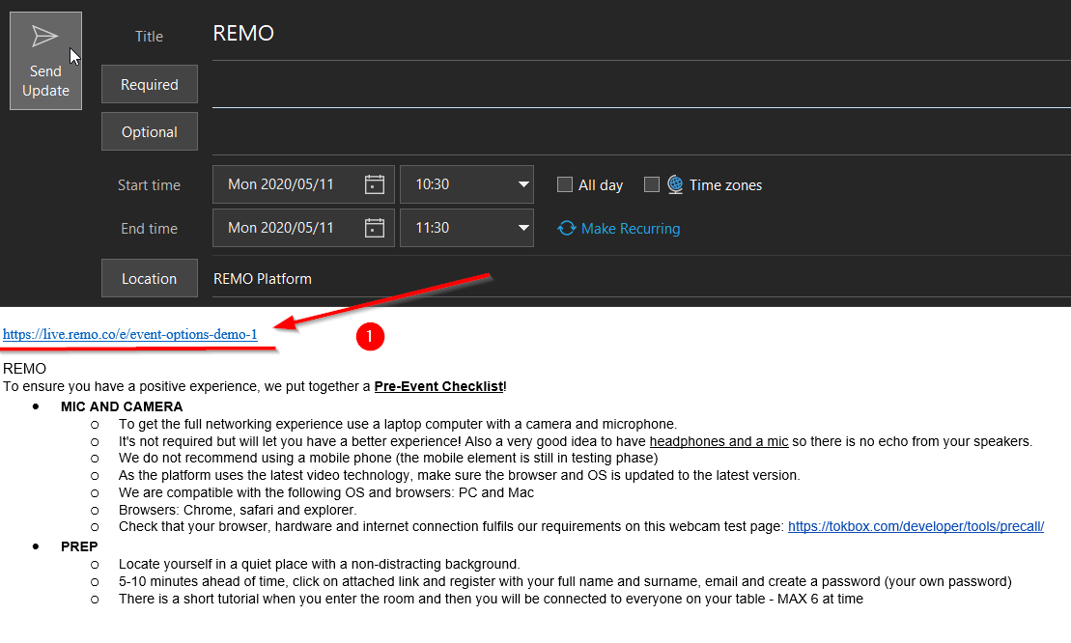
Step 2: Once the website launches, click on Join Event Now highlighted in green
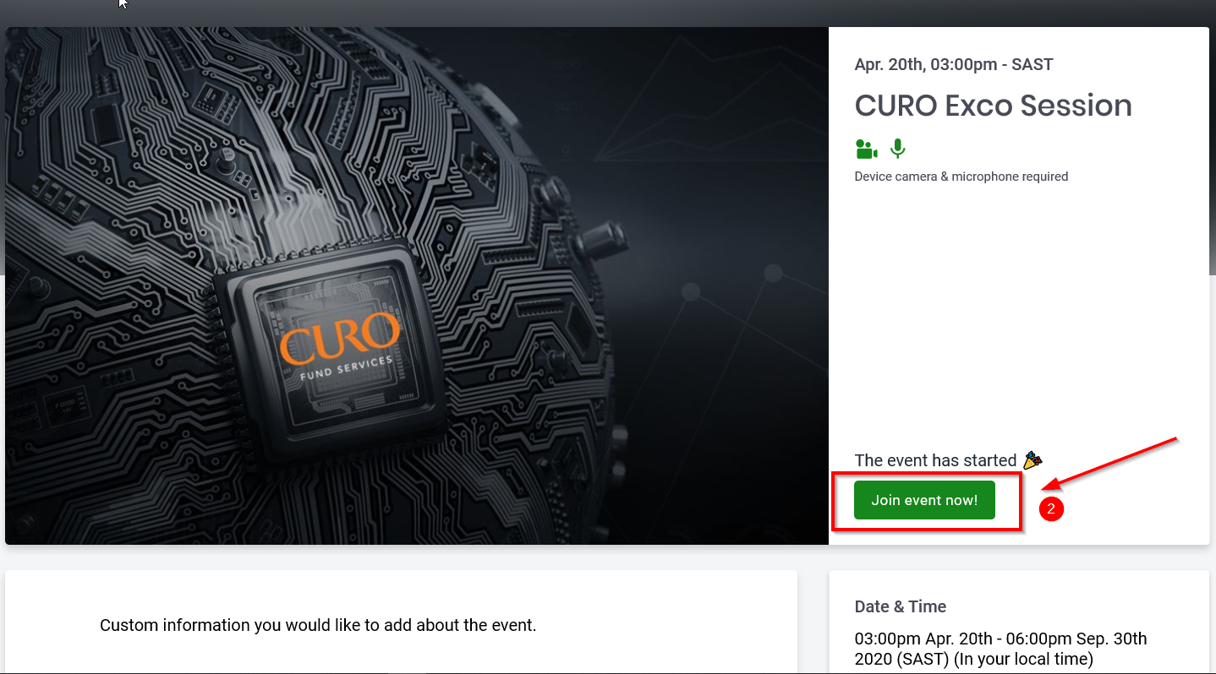

Step 3: You will then be prompted to sign in with your work email address
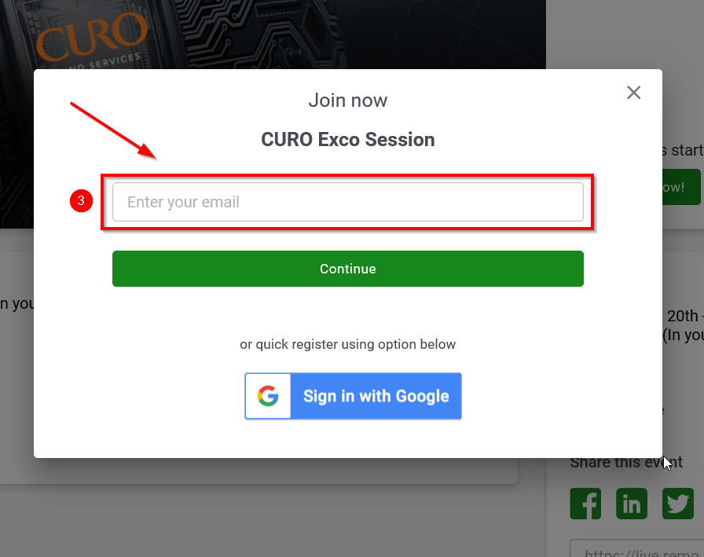
Step 4: Next, you will be promoted to input a password of your choice
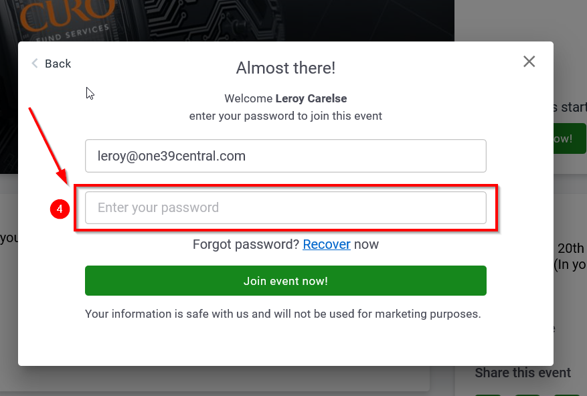
Step 5: Then click on Join Event Now!
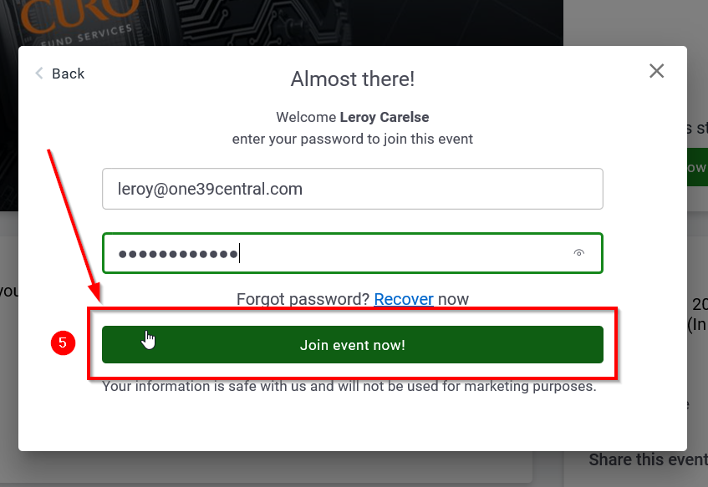
Step 6: Now you will be taken through a few steps (tutorial) to ensure that your laptops settings are correct. Click on Allow camera and microphone highlighted in green.
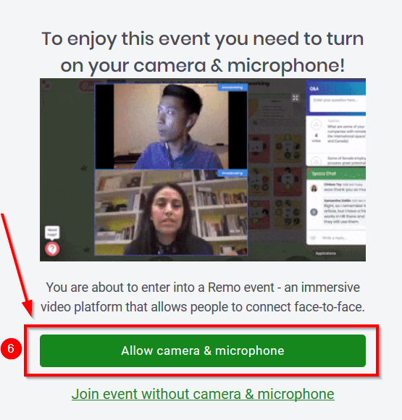
Step 7: Next you will be prompted to allow the platform to access your webcam
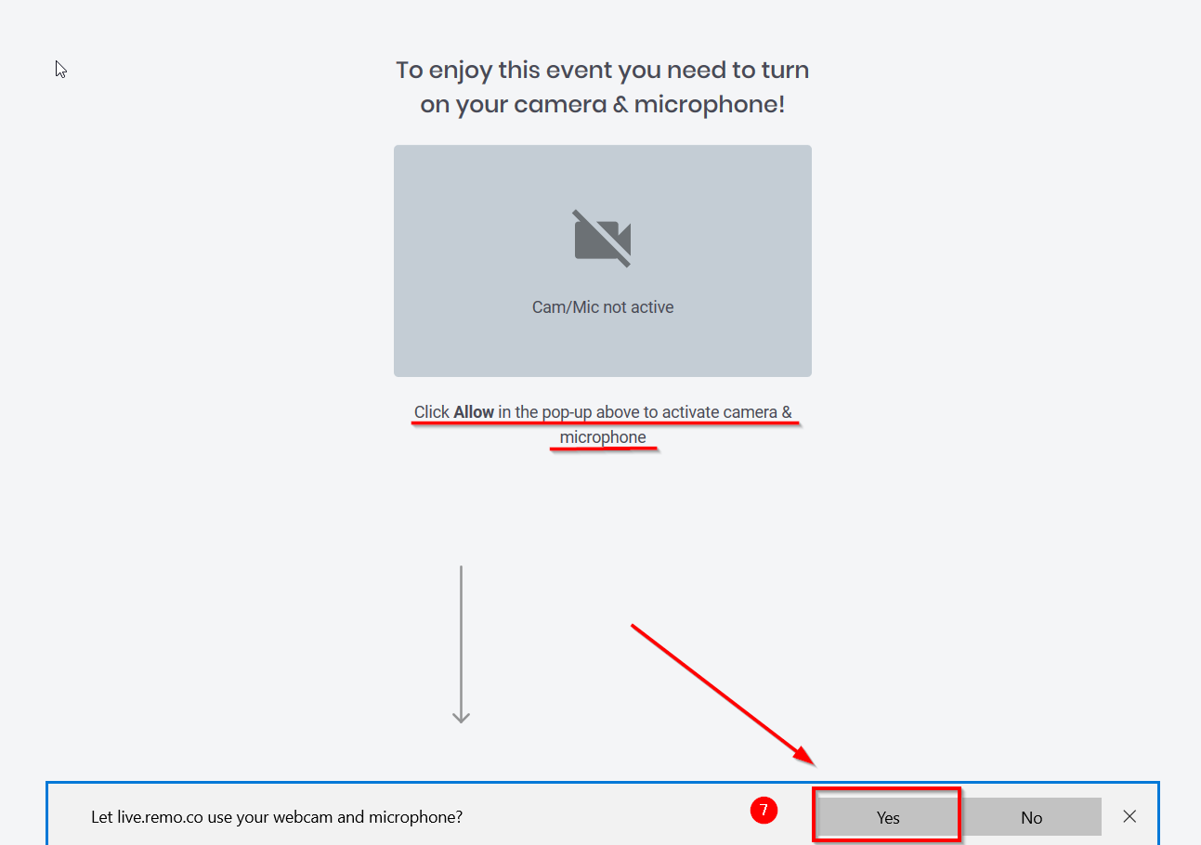

Step 8: You will now be redirected to check your webcam and mic settings. Once completed, click on Cam & Mic works! Join event! highlighted in green.
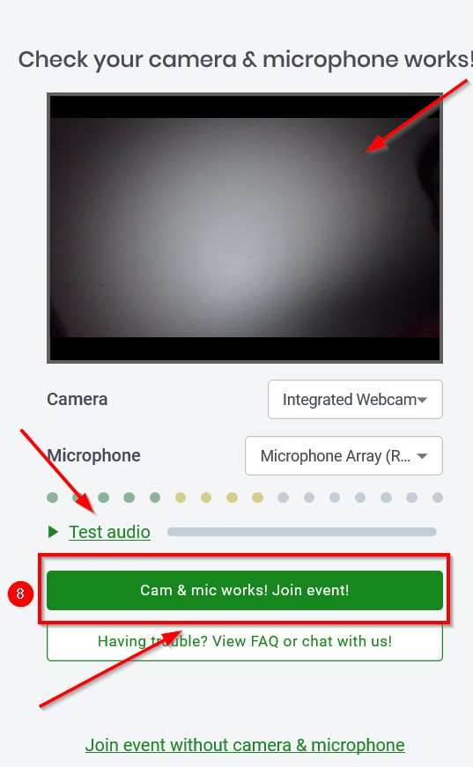
Step 9: Next, you will enter the virtual meeting room and land at any one of the tables. A maximum of 6 guests can sit at any table. Activate camera and mic so you can hear those at your table. You can only hear those guests who are at your table
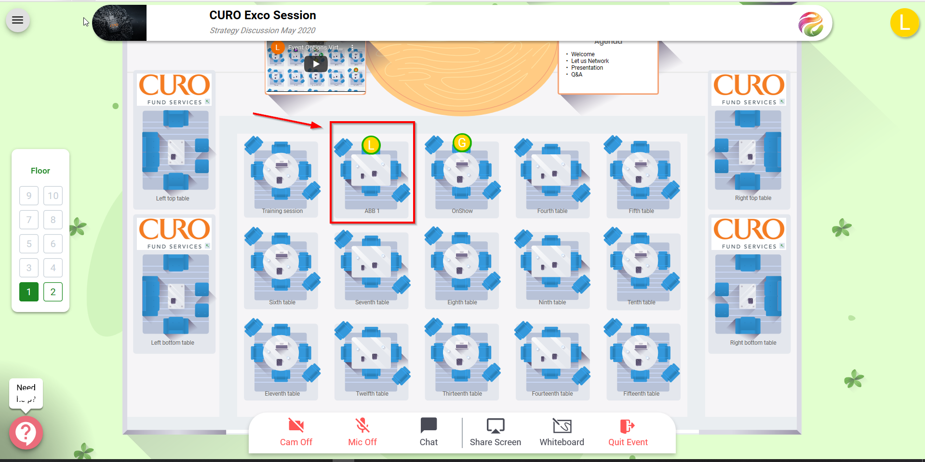

Step 10: You are now able to move around between tables to engage with other delegates. To do so, hover your mouse of the table you wish to move to and double click. You will be able to interchange between tables before and after a presentation (not during).
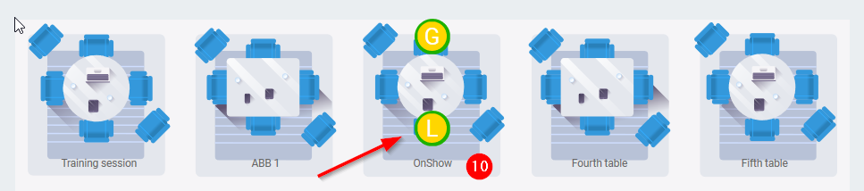
Step 11: Please ensure that you use your control panel to enable/disable your mic, camera and access individual or group chat.
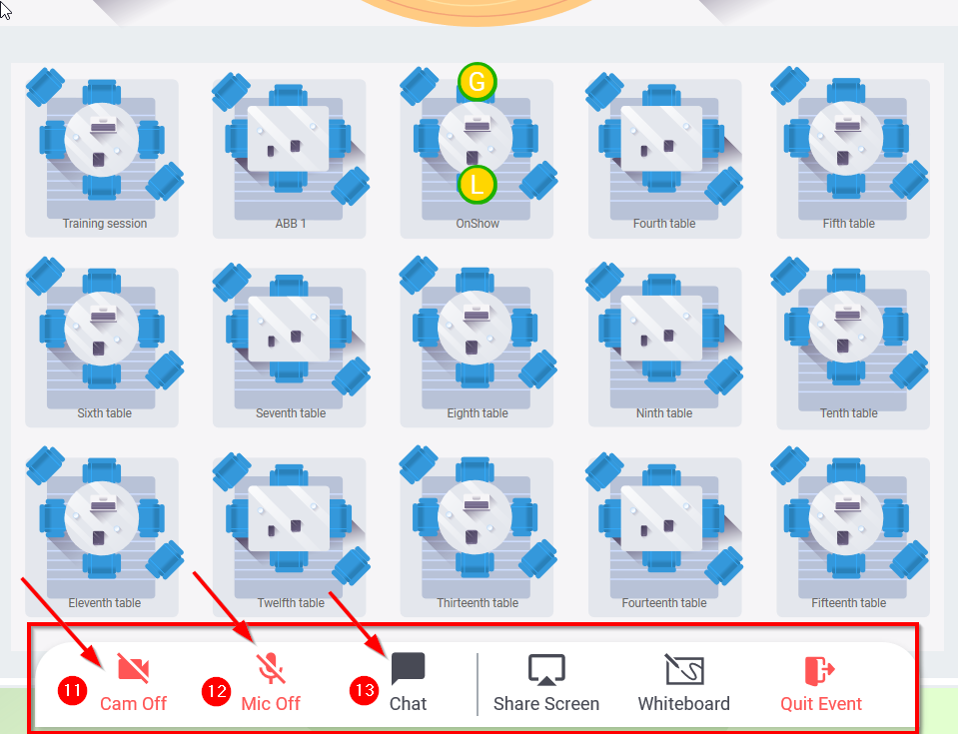

Step 12: Once the presentation starts you will remain at your table (although you wont see this on your screen any more as the presenter with his / her slides and video would be displayed on your screen. Your mic and camera is automatically turned off so the audience is able to focus on the presenter. The speaker is not able to see or hear you. You can however, continue to engage with the audience through chat and Q&A. The speaker wont

Final step: Once your event is completed, please click on Quit Event to exit.
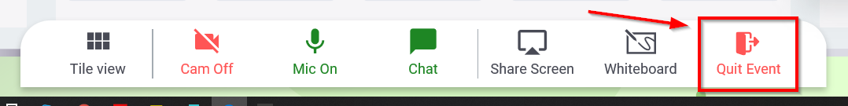

The End!

